Literature Review

[1] Deep Neural Networks Based Recognition of Plant Diseases by Leaf Image Classification

**Authors:** Srdjan Sladojevic, Marko Arsenovic, Andras Anderla, Dubravko Culibrk, and Darko Stefanovic.

* Accepted: 29 May 2016.

**Abstract:** The latest generation of convolutional neural networks (CNNs) has achieved impressive results in the field of image classification.

This paper is concerned with a new approach to the development of plant disease recognition model, based on leaf image classification, by the use of deep convolutional networks. Novel way of training and the methodology used facilitate a quick and easy system implementation in practice.

**Goals:** The main goal of the presented study is to train the network to learn the features that distinguish one class from the others.

**Materials and Methods:**

The entire procedure of developing the model for plant disease recognition using deep CNN is described further in detail.

1. **Dataset:** All the images collected for the dataset were downloaded from the Internet, searched by disease and plant name on various sources in different languages, such as Latin, English, German, Serbian, and Hungarian. Images in the dataset were grouped into fifteen different classes. Thirteen classes represented plant diseases which could be visually determined from leaves. In order to distinguish healthy leaves from diseased ones, one more class was added in the dataset. It contains only images of healthy leaves.
2. In this stage, all duplicated images taken from different sources were removed by developed python script applying the comparing procedure. Finally, a database containing 30880 images for training and 2589 images for validation has been created. 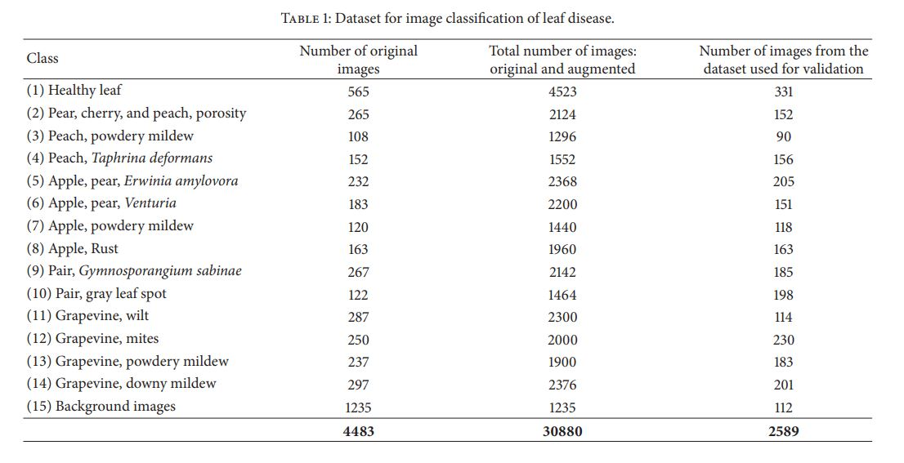
3. Images used for the dataset were image resized to 256 × 256 to reduce the time of training, which was automatically computed by written script in Python, using the OpenCV framework.
4. Augmentation Process. The main purpose of applying augmentation is to increase the dataset and introduce slight distortion to the images which helps in reducing over-fitting during the training stage.

For this stage, in order to automate the augmentation process for numerous images from the dataset, particular application was developed in C++ using the OpenCV library.

1. Neural Network Training: For the purpose of this research, Caffe framework was used, along with the set of weights learned on a very large dataset, ImageNet. CaffeNet is a deep CNN which has multiple layers that progressively compute features from input images [43]. Specifically, the network contains eight learning layers and five convolutional and three fully connected layers.

**Results:** After fine-tuning the parameters of the network, an overall accuracy of 96.3% was achieved, after the 100th training iteration (95.8% without fine-tuning).

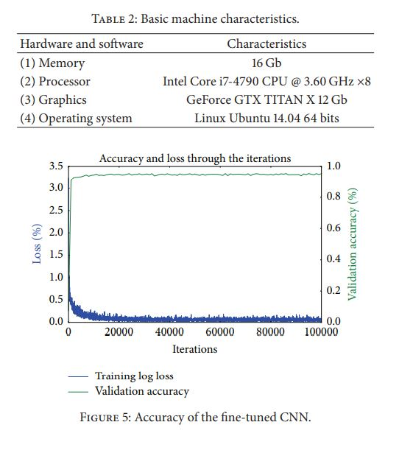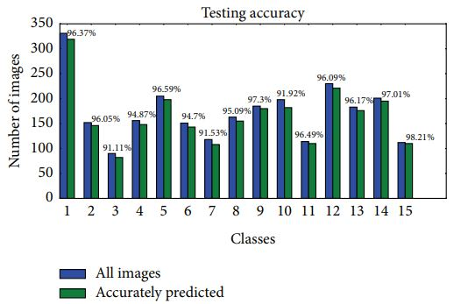

[2] Using Deep Learning for Image-Based Plant Disease Detection

**Authors:** Sharada P. Mohanty, David P. Hughes and Marcel Salathé.

* Published: 22 September 2016

**Abstract:** Crop diseases are a major threat to food security, but their rapid identification remains difficult in many parts of the world due to the lack of the necessary infrastructure.

**Objectives:** Using a public dataset of 54,306 images of diseased and healthy plant leaves collected under controlled conditions, we train a deep convolutional neural network to identify 14 crop species and 26 diseases (or absence thereof).

**Methods:**

* **Dataset Description** : We analyze 54,306 images of plant leaves, which have a spread of 38 class labels assigned to them. Each class label is a crop disease pair, and we make an attempt to predict the crop-disease pair given just the image of the plant leaf. Figure 1 shows one example each from every crop-disease pair from the PlantVillage dataset. In all the approaches described in this paper, we resize the images to 256 × 256 pixels, and we perform both the model optimization and predictions on these downscaled images.

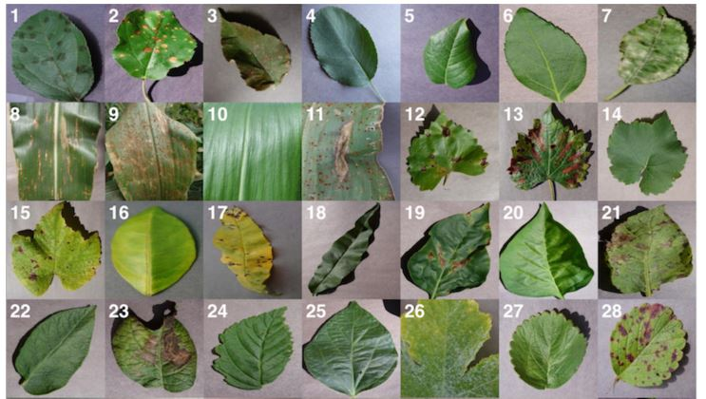

* **Approach:** We focus on two popular architectures, namely AlexNet (Krizhevsky et al., 2012), and GoogLeNet (Szegedy et al., 2015), which were designed in the context of the “Large Scale Visual Recognition Challenge” (ILSVRC) (Russakovsky et al., 2015) for the ImageNet dataset (Deng et al., 2009).

AlexNet consists of 5 convolution layers, followed by 3 fully connected layers, and finally ending with a softMax layer.

The GoogleNet architecture on the other hand is a much deeper and wider architecture with 22 layers, while still having considerably lower number of parameters (5 million parameters) in the network than AlexNet (60 million parameters).

* **hyper-parameters used:** 
  + Solver type: Stochastic Gradient Descent
  + Base learning rate: 0.005
  + Learning rate policy: Step (decreases by a factor of 10 every 30/3 epochs)
  + Momentum: 0.9
  + Weight decay: 0.0005
  + Gamma: 0.1
  + Batch size: 24 (in case of GoogLeNet), 100 (in case of AlexNet).

**RESULTS:**

At the outset, we note that on a dataset with 38 class labels, random guessing will only achieve an overall accuracy of 2.63% on average.

the overall accuracy we obtained on the PlantVillage dataset varied from 85.53% (in case of AlexNet::TrainingFromScratch::GrayScale::80–20) to 99.34% (in case of GoogLeNet::TransferLearning::Color::80–20), hence showing strong promise of the deep learning approach for similar prediction problems.

[3] A Deep Learning-based Approach for Banana Leaf Diseases Classification

**Authors:** Jihen Amara,1 Bassem Bouaziz,2 and Alsayed Algergawy

* Published: 2017-7-9.

**Abstract:**

Plant diseases are important factors as they result in serious reduction in quality and quantity of agriculture products. Therefore, early detection and diagnosis of these diseases are important. However, we limit our study to classify banana leaves diseases. Banana is threatened by different types of diseases, such as banana sigatoka and banana speckle.

The black sigatoka is caused by the fungus Mycosphaerella fijiensis. Its symptoms start by minuscule, chlorotic spots and it then develops into thin brown streaks that are bounded by leaf veins (see Fig.1).

Leaf speckle is a fungal disease. Its symptoms start as light brown little spots and with time they increase in size and become black. Left untreated, these diseases will kill the plant. If, however, they are diagnosed early, they can be treated and the plant can be saved.

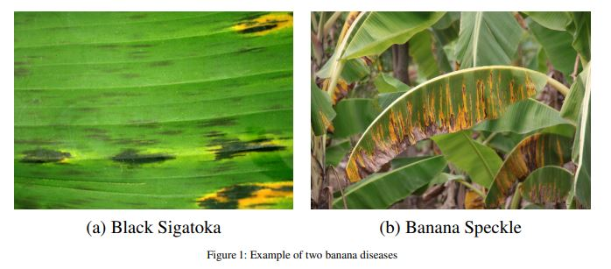

**Objectives:**

we propose a deep learning-based approach that automates the process of classifying banana leaves diseases. In particular, we make use of the LeNet architecture as a convolutional neural network to classify image data sets.

Our method, based on LeNet architecture [Le89] requires minimal image preprocessing. The model can learn visual features directly from images. The developed model is able to recognize two different types of diseased leaves out of healthy ones.

**Proposed method:**

To deal with the mentioned challenges, we introduce a deep learning-based approach to classify and identify banana leaves diseases. The general architecture of the proposed framework is illustrated in Fig. 3. The figure shows that the framework consists of two main components: image preprocessing and deep learning-based classification. In the following, we present details about each component.

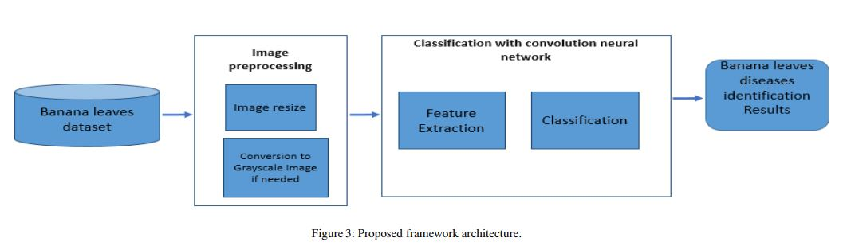

1. **Image preprocessing:** The dataset stored in either local or global repositories contains a large number of images of healthy and infected leaves. The images are taken with a standard digital camera.

Each image has three channels which are red (R), green (G), and blue (B). In our experiments we will test the applicability of our approach to both the RGB images and the grayscale images. To this end, we perform a preprocessing step where each image in our dataset is resized to 60 ⋆ 60 pixels and converted to grayscale.

1. **Deep learning based classification:** As shown in in Fig. 4, a CNN is composed of three main parts which are convolution, pooling and fully connected layers.

The convolution and pooling layers act as feature extractors from the input images while the fully connected layer acts as a classifier.

The essential purpose of convolution is to extract features automatically from each input image. The dimensionality of these features is then reduced by the pooling layer.

At the end of the model, the fully connected layer with a softmax activation function makes use of the learned high-level features to classify the input images into predefined classes.

In summary, the LeNet model is composed of two main parts: the first part is the self-taught feature extraction model and the second part is the classification model. In the rest of this section, we will detail these two components.

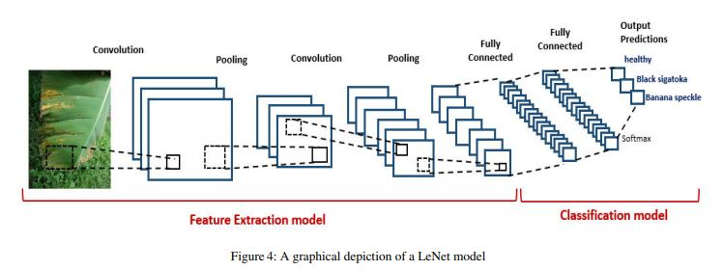

*Hyper Parametrs used:*



In our implementation we used the deeplearning4j 4 as an open source deep learning library which supports the use of GPUs to make the execution of the deep learning algorithms faster.

**Results:**

To evaluate the effectiveness of the proposed system, we make use of a combination of accuracy, precision, recall, and F1-score. Results are reported in Table 2 across all our experimental configurations.

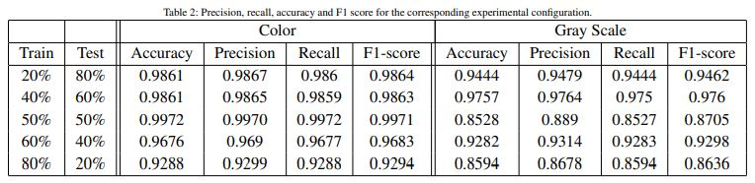

The obtained results confirm the importance of the color information in plant disease identification. Hence, a green color always refers to a healthy leaf while a leaf with black or brown spots may be considered unhealthy.

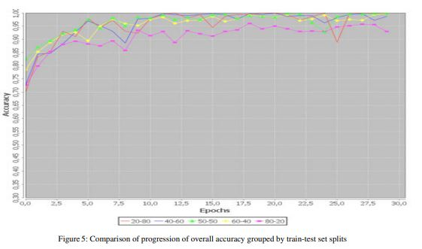

Fig. 5 shows the accuracy of the different train and tests splits choices while the number of iterations is varied. As we can see, in some splits the model takes more time to converge. However in most of the test splits, the model starts to stabilize from iteration 25 and achieve good accuracy at the final iteration.

[4] Image-Based Tomato Leaves Diseases Detection Using Deep Learning

**Authors:** Belal A. M. Ashqar, Samy S. Abu-Naser

* December – 2018

**Abstract:**

Crop diseases are a key danger for food security, but their speedy identification still difficult in many portions of the world because of the lack of the essential infrastructure.

The mixture of increasing worldwide smartphone dispersion and current advances in computer vision made conceivable by deep learning has cemented the way for smart phone-assisted disease identification. Using a public dataset of 9000 images of infected and healthy Tomato leaves collected under controlled conditions, we trained a deep convolutional neural network to identify 5 diseases.

**Study Objectives:**

1. Demonstrating the feasibility of using deep convolutional neural networks to classify plant diseases.
2. Developing a model that can be used by developers to create smartphones application to detect plant diseases.

**Dataset and Methods:**

We choose to work with 9,000 images on Tomato leaves; our dataset contains samples for 5 types of Tomato diseases in addition to healthy leaves, 6 classes in total as follow[16]:

* class (0): Bacterial Spot.
* class (1): Early Blight.
* class (2): Healthy.
* class (3): Septorial Leaf Spot.
* class (4): Leaf mold.
* class (5): Yellow Leaf Curl Virus.

The images were resized into 150×150 for faster computations.

We experimented with two types of images to see how the model work and what exactly it learns, first we take the image as it is with 3 color channels, and then we experimented with 1 color channel images (Gray-Scale). And as expected the model learns different patterns in each approach.

**Model:** Our model takes raw images as an input, so we used Convolutional Nural Networks (CNNs) to extract features, in result the model would consist of two parts:

1. The first part of the model (features extraction), which was the same for full-color approach and gray-scale approach, it consist of 4 Convolutional layers with Relu activation function, each followed by Max Pooling layer.
2. The second part after the flatten layer contains two dense layers for both approaches, but in full-color the first has 256 hidden units which makes the total number of network trainable parameters 3,601,478, in the other hand gray-scale approach has 128 hidden units in the first dense layer and 1,994,374 as total trainable parameters, we shrank the size of the gray-scale network to avoid overfitting, for the last layer for both has Softmax as activation and 6 outputs representing the 6 classes.

**Conclusion:**

We are so proud to show that out best model (Full-Color) achieved an accuracy of 99.84% on a held-out test set, and second best model (Gray-Scale) achieved an accuracy of 95.54%, Figures 5 and 6 show how the models accuracy progress over epochs (as seen in Figure5-Figure8).

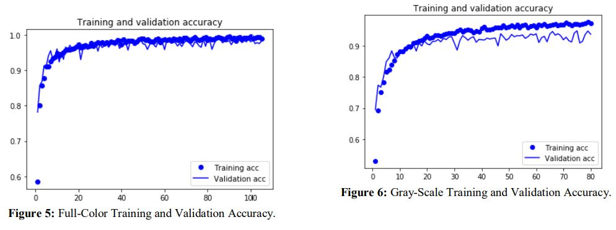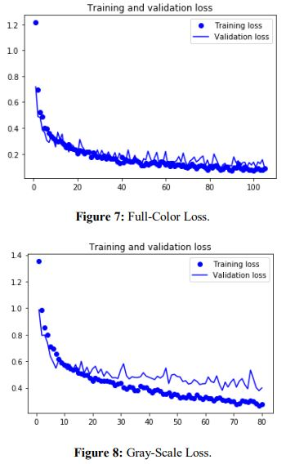

**Links to the full papers:**

1. Deep Neural Networks Based Recognition of Plant Diseases by Leaf Image Classification: <https://www.hindawi.com/journals/cin/2016/3289801/abs/>
2. Using Deep Learning for Image-Based Plant Disease Detection: <https://www.frontiersin.org/articles/10.3389/fpls.2016.01419/full>
3. A Deep Learning-based Approach for Banana Leaf Diseases Classification: <https://pdfs.semanticscholar.org/adae/9446cb66eaa6645dca78fd81b21d43aebdda.pdf>
4. Image-Based Tomato Leaves Diseases Detection Using Deep Learning: <http://dstore.alazhar.edu.ps/xmlui/handle/123456789/278>